A Mechanical Description of a Garlic Press

by

Shadi Jiha

ID: 40131284

Assignment 1

ENCS 282

Concordia University

February 2020

DESCRIPTION OF A GARLIC PRESS

**Introduction – General Description**

This document provides the manufacturing specifications for the “garlic press”– a common kitchen tool. This tool is also known as “garlic crusher”; This document uses both terms interchangeably. This tool is mostly used to extract the garlic from its skin by forcing it to go through a grid with relatively small holes. The tool can also be used to extract the seed of an olive.

The dimensions of the garlic press may vary depending on the model, but the overall shape and mechanism is always conserved. This particular model has a length of 196 mm[1], a width of 55 mm1 and a depth of 32 mm1. When fully opened – when the presser is at 180 degrees from the handle, the unit’s length expands to 301 mm1.

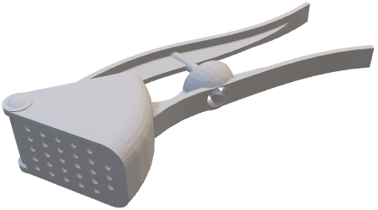

FIGURE 1 **An overall view of the garlic crusher**

***Source: Messai, 2014, https://grabcad.com/library/garlic-press-2***

Grid

Presser

Handle

Olive seed exit

Olive seed Presser

Garlic container

Garlic exit

Olive container

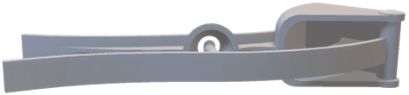

FIGURE 2 **A back view of the garlic crusher**

***Source: Messai, 2014, https://grabcad.com/library/garlic-press-2***

Piston

Presser

Handle

Olive container

This machine has six main parts: garlic container, presser, handle, grid, olive seed presser, and olive container (Figure 1).

**Description of Parts and Their Function**

The **Grid** is a rectangular metal that contains an array of small hole each with a diameter of 3 mm. The extracted garlic exists through these holes while the unwanted remaining skin stays on the back of the grid.

The **Garlic container** is a box shaped metallic small space that holds the garlic bulb in place.

The **Presser** is the longest part of the garlic crusher. It is a metallic bar where the user’s force is applied.

The **Piston** is a rectangular metal attached to the presser. The piston transfers the force applied onto the presser to the garlic bulb to force it through the grid.

The **Handle** is another metallic bar that faces the user’s fingers when using the tool. This part must be immobile during the usage to allow the presser to do its job properly

The **Olive container** is a cone shaped metal that holds an olive for the alternative use of this tool.

The **Olive seed presser** is a small metallic cylinder that does through the olive and forces its seed through the olive seed exit. The presser is the part responsible of providing force to this part

**Operating Description and Conclusion**

The main use of this tool is garlic extraction from the unwanted skin. The overall mechanism is the following, a garlic bulb is paced inside the garlic container. The crusher is placed in one’s hand with the handle facing the ground. The handle must remain immobile while a force is applied on the presser. The presser pushes the piston with the latter forcing the garlic bulb through the array of holes on the grid. The essence of the garlic bulb exists through the grid with a cylindric shape.

An alternative use of this machine is olive seed extraction. The mechanism is really similar to the garlic extraction. However, this time, the olive is placed in the olive container. A force is then applied to the presser that forces the olive seed presser through the olive and forces the olive seed to exit through the olive seed exit.

With proper usage, the garlic press can separate almost all the garlic contained in a bulb from its skin. The skin remains in the container after the use and is easily removed and cleaned with some water.

**Bibliography**

Messai, H. (2014, April 16). Garlic Press CAD Design & 3D Model. Retrieved February 13, 2020, from <https://grabcad.com/library/garlic-press-2>

Garlic press. (2020, January 10). Retrieved February 13, 2020, from <https://en.wikipedia.org/wiki/Garlic_press>

Moon, A. (2019, March 12). Parts of the Garlic Plant. Retrieved February 13, 2020, from <https://www.gardenguides.com/114271-parts-garlic-plant.html>

Neveu, C., Smith, M., & Last, S. (2019, January 1). 7.4 Technical Descriptions and Definitions. Retrieved February 13, 2020, from <https://pressbooks.bccampus.ca/technicalwriting/chapter/technicaldescriptions/>

Bahnasawy, A. H. (2007, November 28). Some Physical and Mechanical Properties of Garlic. Retrieved February 13, 2020, from <https://www-degruyter-com.lib-ezproxy.concordia.ca/view/j/ijfe.2007.3.6/ijfe.2007.3.6.1136/ijfe.2007.3.6.1136.xml>

1. All measures mentioned have a tolerance of $±$ 1 mm